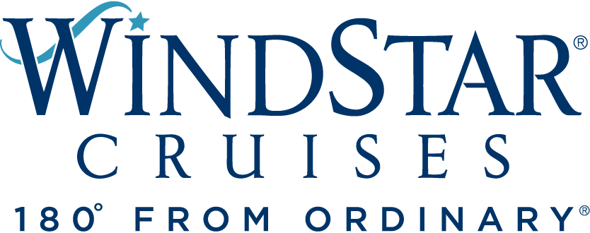

Windstar Cruises Unveils New Shipboard Mural from Miami Artists we are nice’n easy
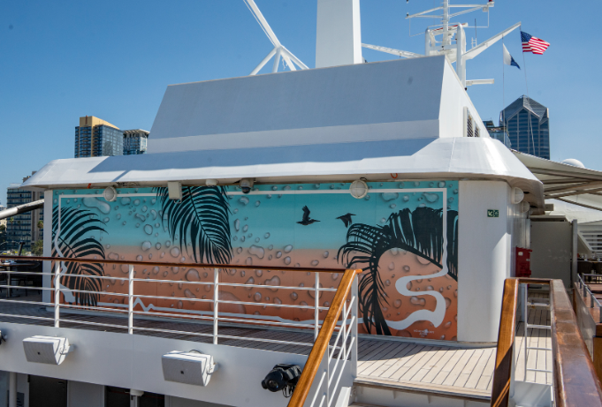
Mural is first of three works to debut on Windstar’s all-suite, Star Plus yachts
MIAMI, FL, October 5, 2022 – Small ship cruise line Windstar Cruises is thrilled to debut the first of three onboard murals as part of a collaboration with Miami-based Fountainhead Arts. Fountainhead selected three different Miami artists to board three of Windstar’s ships to create murals this fall and winter. The murals adorn the large top deck wall aft of the Star Grill on Star Breeze, Star Legend, and Star Pride.

we are nice’n easy recently completed a tropical mural on Star Breeze as it sailed from Vancouver to San Diego in September. Husband and wife artists Allison Matherly and Jeffrey Noble collaborate together under the moniker we are nice’n easy, and they focus on creating immersive, mixed media installations. They describe their work as “developing a visually cohesive subtropical vernacular with our material choices and use of repeated motifs.”

High resolution images of the mural and artists are available here. See the artists in action on Star Breeze on Instagram here.

While Allison and Jefferey were aboard Star Breeze to paint the mural, guests were able to observe them at work and attend a “reveal” event. After the event, they hosted a table at dinner with VIP guests, as well as conducted an evening seminar for guests and crew explaining the mural’s conception, design, meaning, and installation process.

Future Windstar mural installs/programming include artist Magnus Sodamin, beginning on 10/23 aboard Star Pride (sailing from Boston to San Juan) and Elaine Defibaugh, beginning 12/3 aboard Star Legend (sailing from Lisbon to Miami). As this sailing ends in Miami on 12/17, it will allow a chance for Miami’s media and select members of the local arts community to view this work in person.

For more information on Windstar Cruises and all of its itineraries, visit www.windstarcruises.com.

###
Contacts:
Sarah Scoltock, Director of Public Relations, Windstar Cruises / sarah.scoltock@windstarcruises.com
Sally Spaulding, Account Director, Percepture / sspaulding@percepture.com

About Windstar Cruises
Windstar Cruises operates a fleet of six boutique all-suite and sailing yachts carrying 148-342 guests. Small ship cruises sail throughout Europe, the Caribbean, Costa Rica and the Panama Canal, Asia, Alaska and British Columbia, Canada and New England, Tahiti and the South Pacific, Mexico and U.S. Coastal, Arabia and Australia. Three Star Plus Class yachts emerged recently from a $250 Million Star Plus Initiative which added new suites, restaurants, and a world-class spa and fitness center. The award-winning line is known for immersive experiences, destination authenticity, port-intensive itineraries, exceptional service, and an innovative culinary program. Windstar Cruises is part of the Xanterra Travel Collection, a group of global hospitality and travel companies, one of which traces its history back over a hundred years of operating our country’s iconic national parks, including Grand Canyon, Yellowstone, Glacier, Death Valley, and many others. Xanterra Travel Collection is owned by The Anschutz Corporation, the ultimate owner of the Broadmoor, Sea Island, and entertainment giant AEG, Anschutz Entertainment Group.

