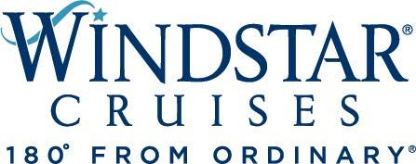

Windstar Cruises Launches New Ad Campaign and Holiday Sale

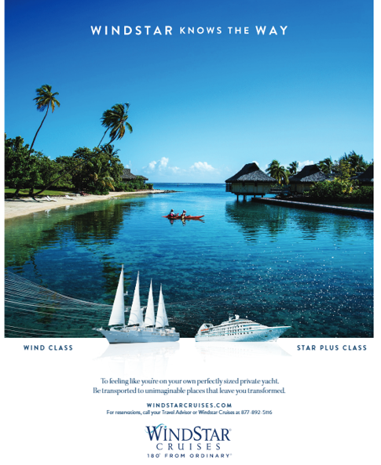

12 Ways of Windstar holiday sale runs 12/14-28

SEATTLE, WA, December 7, 2021 – U.S. headquartered Windstar Cruises launched its new ad campaign today touting that “The Wind and Stars Know the Way.”
The campaign advertises Windstar as a unique, small ship cruise product, more clearly conveying the two classes of small yachts the company operates under one definable brand experience.
Guests can choose between Windstar’s classic sailing yachts (three Wind Class yachts) and luxury all-suite yachts (three newly renovated Star Plus Class yachts) – ergo, “The Stars Know the Way” and “The Wind Knows the Way” in the new campaign materials, together forming the brand name WindStar.
“We believe in giving guests the power to choose how they sail and then delivering the benefits of small ship cruising in ways that boldly claim a competitive advantage,” says Windstar President Christopher Prelog. “With this new messaging, we have the opportunity to share the personalized approach and perspective each of our ship classes inspire, including visualizing key off-ship and onboard attributes of Windstar, such as feeling like you’re on your own private yacht with only 148 to 342 guests on board.”
Prelog believes the messaging will resonate with existing guests who know the brand well and inspire new potential customers and convert them into first time cruisers on Windstar. Look for the new messaging in print and digital ads, social, and video, as well as a new landing page on Windstar’s website.
And on the heels of a successful Black Friday/Cyber Monday “Book Your Bucket List” sale, Windstar is gearing up for its 12 Ways of Windstar holiday sale, running December 14-28. Cruise rates will be reduced on select departures with a lead rate of $1,499 per person, based on double occupancy. Travelers will find great deals on cruises in the Caribbean, Mediterranean, Black Sea and Holy Lands, U.S. Coastal, Tahiti and Trans-Ocean.
Windstar’s Beyond Ordinary Care health and safety program requires everyone aboard to be vaccinated. For more details on Windstar Cruises, visit www.windstarcruises.com.
###
Contacts:
Sarah Scoltock, Director of Public Relations, Windstar Cruises / sarah.scoltock@windstarcruises.com
Sally Spaulding, Account Director, Percepture / sspaulding@percepture.com

About Windstar Cruises
Windstar Cruises operates a fleet of six boutique all-suite and sailing yachts carrying 148-342 guests. Small ship cruises sail throughout Europe, the Caribbean, Costa Rica and the Panama Canal, Asia, Alaska and British Columbia, Canada and New England, Tahiti and the South Pacific, Mexico and U.S. Coastal and Australia. Windstar launched the $250 Million Star Plus Initiative to transform the three all-suite Star Plus Class yachts with new suites, restaurants, and a world-class spa and fitness center. The award-winning line is known for immersive experiences, destination authenticity, port-intensive itineraries, exceptional service, and an innovative culinary program. Windstar Cruises is part of the Xanterra Travel Collection, a group of global hospitality and travel companies, one of which traces its history back over a hundred years of operating our country’s iconic national parks, including Grand Canyon, Yellowstone, Glacier, Death Valley, and many others. Xanterra Travel Collection is owned by The Anschutz Corporation, the ultimate owner of the Broadmoor, Sea Island, and entertainment giant AEG, Anschutz Entertainment Group.

