Windstar Announces Chefs for

2023 James Beard Foundation® Culinary Themed Cruises

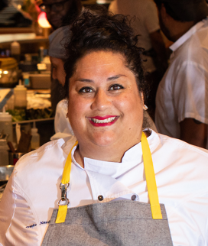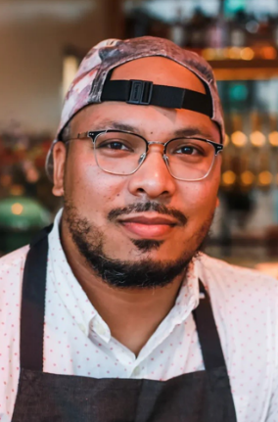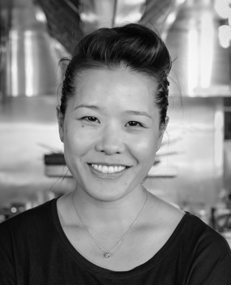

(Images: Left to right are Nurdjaja, Grant, and Chang)
MIAMI, FL, September28, 2022 – Small ship cruise line Windstar Cruises has announced its lineup of James Beard Foundation®-affiliated guest chefs for its series of three themed culinary cruises in 2023. The trio of acclaimed visiting chefs include D.C.’s Jerome Grant; New York’s Ayesha Nurdjaja; and Boston’s Tracy Chang.
Windstar is the Official Cruise Line of the James Beard Foundation (JBF). The nonprofit organization’s mission is to celebrate, support, and elevate the people behind America’s food culture and champion a standard of good food anchored in talent, equity, and sustainability. The Foundation firmly aligns with Windstar’s commitment to fresh and local epicurean experiences around the world, as well as efforts to reduce food waste.
All three themed cruises in 2023, detailed at the links below, include two on-board cooking demonstrations, as well as four dishes by the JBF visiting chef at a hosted dinner with wine pairings. Each chef will also lead a market tour, gathering fresh and local ingredients for dishes served on board. In addition, all three chefs will provide multiple recipes to be featured on Windstar’s menus across all cruises—adding to a growing menu of James Beard Foundation-affiliated chefs’ special menu items, served across the fleet on every sailing.
“As the Official Cruise Line of the James Beard Foundation, we’ve hosted dozens of top chefs over the years. One of the best byproducts possible is a delicious and constantly rotating selection of JBF dishes on our menu – on all of our sailings,” explains Windstar President Christopher Prelog. "It doesn’t get any better than sailing with a James Beard Foundation guest chef on a special culinary cruise. Not only will you get to eat their food—you’ll get to know them. You may even learn a few tips and tricks for being a better cook yourself, and you’ll definitely have a richer and deeper travel experience because of it.”
3/4-11, 2023 on Star Legend in the Caribbean, from Panama City to Oranjestad with Chef Jerome Grant
Jerome Grant grew up mostly in the United States—New York, Oklahoma, California, Maryland—and picked up the basics of Filipino cuisine from his mother and the Caribbean flavors of his Jamaican heritage from his paternal grandparents. After graduating from Pennsylvania Culinary Institute, Grant moved to the U.S. Virgin Islands, where he gained his first critical notice while helming the Renaissance St. Croix Carambola Beach Resort. Back stateside, Grant accepted an executive sous chef position at Urbana Restaurant in Washington, D.C. before working as executive chef of the Mitsitam Native Foods Café inside the National Museum of the American Indian. Grant then became the inaugural chef of the Sweet Home Café inside the National Museum of African American History and Culture. His recipes and menus took the café from a simple concept to becoming a James Beard Award recognized restaurant and cookbook. Since 2020, Grant has been with Dacha Restaurant Group in D.C., including Jackie Restaurant, which pays homage to Grant’s Filipino-American roots, and Dacha Beer Gardens. He’s also preparing for the upcoming launch of Mahal, an open-fire kitchen.
Grant is a 2019 James Beard Restaurant and Chef Award Semifinalist for Best Chef Mid-Atlantic. Sweet Home Café is a 2017 James Beard Restaurant and Chef Award Semifinalist for Best New Restaurant, and the restaurant is inspiration for the 2019 James Beard Media Award Nominated “Sweet Home Café Cookbook.”
Grant is excited to join Windstar in the Caribbean, reconnecting with the Caribbean flavors of his Jamaican heritage along the way.
6/17-26, 2023 on Wind Surf in the Mediterranean, from Venice to Athens with Ayesha Nurdjaja
Ayesha Nurdjaja is the executive chef at Shuka in New York City’s SoHo neighborhood, as well as sibling restaurant Shukette. Born and raised in Brooklyn, she is the daughter of an Indonesian father and Italian mother. Nurdjaja graduated from culinary school in 2006 and, after watching chef Lidia Bastianich cook on PBS, walked into Lidia’s restaurant, Felidia, and asked for a job. They brought her on as a line cook and she worked her way up the ranks to become sous chef. Since then, Nurdjaja has helped lead the kitchen teams at Bar Artisanal, Michelin-starred Picholine, and at Michelin-starred A Voce under chef Missy Robbins. She also spent time as executive chef at Il Bordello and most recently at Brooklyn neighborhood favorite Red Gravy, where she offered her take on modern southern Italian cuisine. In 2015, Nurdjaja joined with restaurateurs Vicki Freeman and Marc Meyer to create Shuka, with a menu that draws on the vibrant flavors found throughout Italy, Morocco, and Tunisia. Shukette followed to great acclaim in 2021.
Nurdjaja is a 2022 James Beard Restaurant and Chef Award Nominee for Best Chef: New York State.
Nurdjaja is a frequent traveler to the Aegean Sea and is thrilled to lead Windstar guests on a culinary journey in one of her most favorite places on the planet.
9/21-30, 2023 on Star Breeze in Asia, from Tokyo to Osaka, Japan with Chef Tracy Chang
Tracy Chang is the chef/owner of PAGU restaurant in Cambridge, MA, celebrating Spanish and Japanese style tapas paired with natural wines, sakes, sherry, and more. Chang’s love for the restaurant industry began at an early age—her grandmother immigrated to Boston in the 1980s and opened several Japanese restaurants. Prior to PAGU, Chang founded a pop-up restaurant, Guchi’s Midnight Ramen, and hosted events with restaurants, startups, nonprofits, and universities, including Harvard, where she is a teaching fellow. During COVID-19, she co-founded two nonprofit initiatives, Off Their Plate (OTP) and Project Restore Us (PRU), to provide essential worker communities with food and groceries. The standard operating procedures she created for her restaurant PAGU, as well as for Off Their Plate, have been compiled into a comprehensive guide by the James Beard Foundation, World Central Kitchen, and the Aspen Institute.
Chang is an alumna of the James Beard Foundation Chef Bootcamp for Policy & Change, James Beard Foundation Women’s Entrepreneurship Leadership Program, and a 2020 James Beard Restaurant and Chef Award Semifinalist for Best Chef: Northeast.
Chang looks forward to sailing in Japan—exploring her family’s roots and celebrating her grandmother’s culinary legacy in the process.
Downloadable images of the chefs are available here.
For more details on Windstar Cruises, visit www.windstarcruises.com.
###
Contacts:
Sarah Scoltock, Director of Public Relations, Windstar Cruises / sarah.scoltock@windstarcruises.com
Sally Spaulding, Account Director, Percepture / sspaulding@percepture.com

About Windstar Cruises
Windstar Cruises operates a fleet of six boutique all-suite and sailing yachts carrying 148-342 guests. Small ship cruises sail throughout Europe, the Caribbean, Costa Rica and the Panama Canal, Asia, Alaska and British Columbia, Canada and New England, Tahiti and the South Pacific, Mexico and U.S. Coastal and Australia. Windstar launched the $250 Million Star Plus Initiative to transform the three all-suite Star Plus Class yachts with new suites, restaurants, and a world-class spa and fitness center. The award-winning line is known for immersive experiences, destination authenticity, port-intensive itineraries, exceptional service, and an innovative culinary program. Windstar Cruises is part of the Xanterra Travel Collection, a group of global hospitality and travel companies, one of which traces its history back over a hundred years of operating our country’s iconic national parks, including Grand Canyon, Yellowstone, Glacier, Death Valley, and many others. Xanterra Travel Collection is owned by The Anschutz Corporation, the ultimate owner of the Broadmoor, Sea Island, and entertainment giant AEG, Anschutz Entertainment Group.
About the James Beard Foundation
The James Beard Foundation (JBF) is a 501(c)3 nonprofit organization that celebrates and supports the people behind America’s food culture, while pushing for new standards in the restaurant industry to create a future where all have the opportunity to thrive. Established over 30 years ago, the Foundation has highlighted the centrality of food culture in our daily lives and is committed to supporting a resilient and flourishing industry that honors its diverse communities. By amplifying new voices, celebrating those leading the way, and supporting those on the path to do so, the Foundation is working to create a more equitable and sustainable future—what we call Good Food for Good®. JBF brings its mission to life through the annual Awards, industry and community-focused programs, advocacy, partnerships, and events across the country. For the first time in the Foundation’s history, thousands of visitors and food and beverage professionals will be able to reimagine James Beard’s legacy and experience unforgettable culinary programming at the Pier 57 food hall—coming soon—that will inspire food-lovers for decades to come. Learn more at jamesbeard.org, sign up for our Beard Bites newsletter, and follow @beardfoundation on Facebook, Twitter, Instagram, TikTok, and LinkedIn for the latest information.

