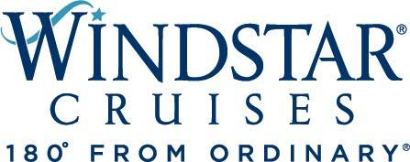

Windstar Cruises Adds All-Inclusive Pricing

for Luxury of Choice

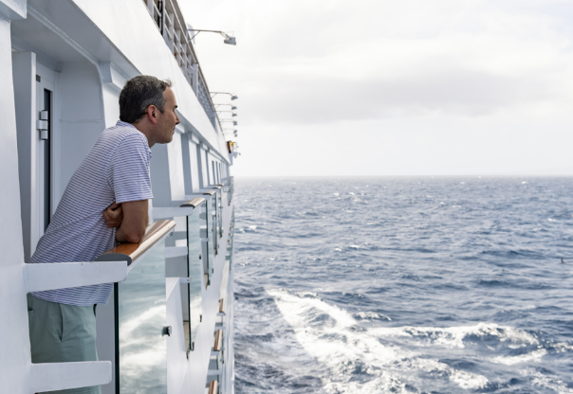

À La Carte Cruise Option Remains for Those Who Enjoy the Freedom to Choose
SEATTLE, WA, November 16, 2021 – U.S. headquartered Windstar Cruises is changing the way it sells cruises. Previously the small ship line had a base cruise fare, with an option to add things like alcohol, gratuities, and other onboard services on top.
“In an effort to be more in line with other luxury offerings in the cruise industry, particularly with the rollout of our newly transformed all-suite Star Plus Class yachts, we’re now giving the option of an all-inclusive price for all of our sailings,” said Windstar President Christopher Prelog. “We didn’t want to take away the à la carte option from guests who enjoy going that way. We want our guests to have the choice based on their preference, what they need on board, and their general vacation philosophy.”
The all-inclusive prices are now listed on Windstar’s website and all sales materials, along with the base cruise fares, which are listed per person in U.S. dollars based on double occupancy. For Windstar, all-inclusive means unlimited wine, beer, and cocktails; Wi-Fi; all gratuities; as well as the cruise fare. The new fare is available for the Wind Class yachts as well.
“We thought about only offering the all-inclusive fare on the newly transformed Star Plus Class yachts,” said Prelog. “But after talking and listening to our repeat guests and valued Travel Advisors, we found some like to go à la carte and only purchase amenities as they go. After discussing internally, we all came to the same conclusion – why not offer both on all our yachts? We offer a choice between sailing yachts and all-suite yachts, and now a la carte or all-inclusive. That seems to fit the Windstar brand.”
Windstar’s Beyond Ordinary Care health and safety plan requires guests and crew to be vaccinated against COVID-19. Beginning January 1, the line’s policies include a free COVID-19 antigen test at the pier for embarking guests. To ease travel back home at the end of the cruise, guests may also choose to purchase antigen ($69) or PCR tests ($135) in advance of their cruise or on board to take prior to departure from the yacht to comply with CDC policies currently requiring negative tests prior to flying into the United States. Any additional testing required by specific ports during the cruise may be purchased on board for guests’ convenience.
For more details on Windstar Cruises, visit www.windstarcruises.com.
###
Contacts:
Sarah Scoltock, Director of Public Relations, Windstar Cruises / sarah.scoltock@windstarcruises.com
Sally Spaulding, Account Director, Percepture / sspaulding@percepture.com

About Windstar Cruises
Windstar Cruises operates a fleet of six boutique all-suite and sailing yachts carrying 148-342 guests. Small ship cruises sail throughout Europe, the Caribbean, Costa Rica and the Panama Canal, Asia, Alaska and British Columbia, Canada and New England, Tahiti and the South Pacific, Mexico and U.S. Coastal and Australia. Windstar launched the $250 Million Star Plus Initiative to transform the three all-suite Star Plus Class yachts with new suites, restaurants, and a world-class spa and fitness center. The award-winning line is known for immersive experiences, destination authenticity, port-intensive itineraries, exceptional service, and an innovative culinary program. Windstar Cruises is part of the Xanterra Travel Collection, a group of global hospitality and travel companies, one of which traces its history back over a hundred years of operating our country’s iconic national parks, including Grand Canyon, Yellowstone, Glacier, Death Valley, and many others. Xanterra Travel Collection is owned by The Anschutz Corporation, the ultimate owner of the Broadmoor, Sea Island, and entertainment giant AEG, Anschutz Entertainment Group.

